PIR SENSOR WITH ARDUINO SIMULATION

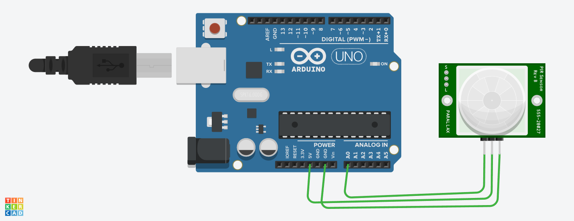

CODE:

Int a=0;

int b=0;

void setup()

{

Serial.begin(9600);

pinMode(13, OUTPUT);

}

void loop()

{

a=analogRead(A0);

b=map(a,0,1023,0,255);

Serial.println(b);

if(b>100)

{

Serial.println("motion detected");

delay(100);

}

}